~ I have used tilt for Home Directory
pwd: Present Working Directory
/: Forward Slash: is used for represent the root directory
Ls: We can find all the Files and folder
echo $0: details of current shell
Date: it will show the date
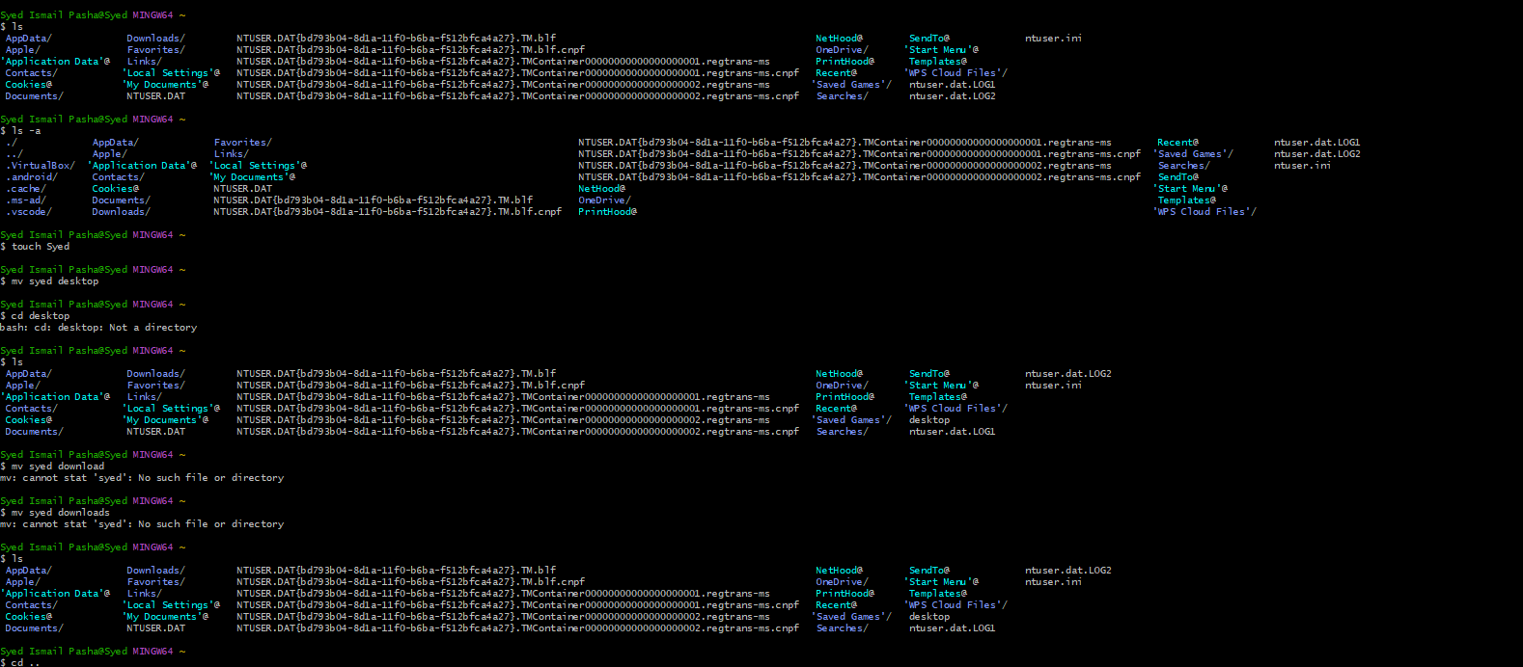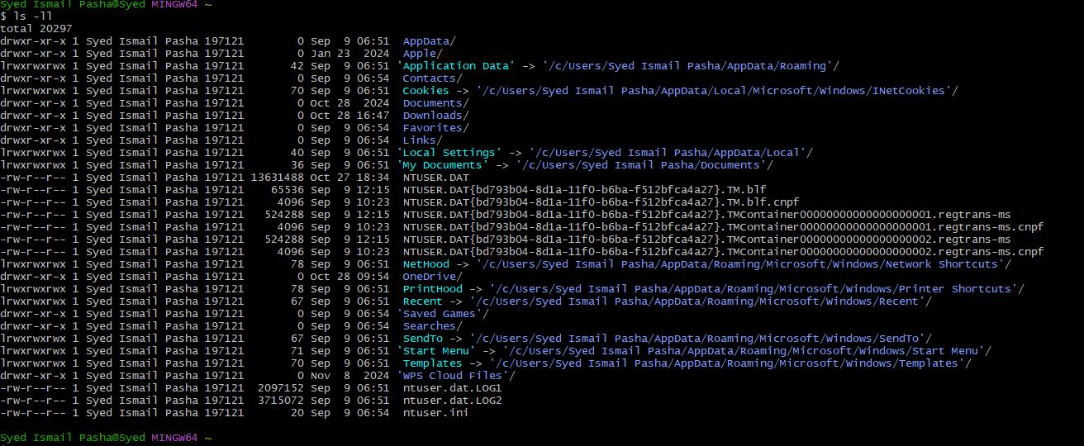
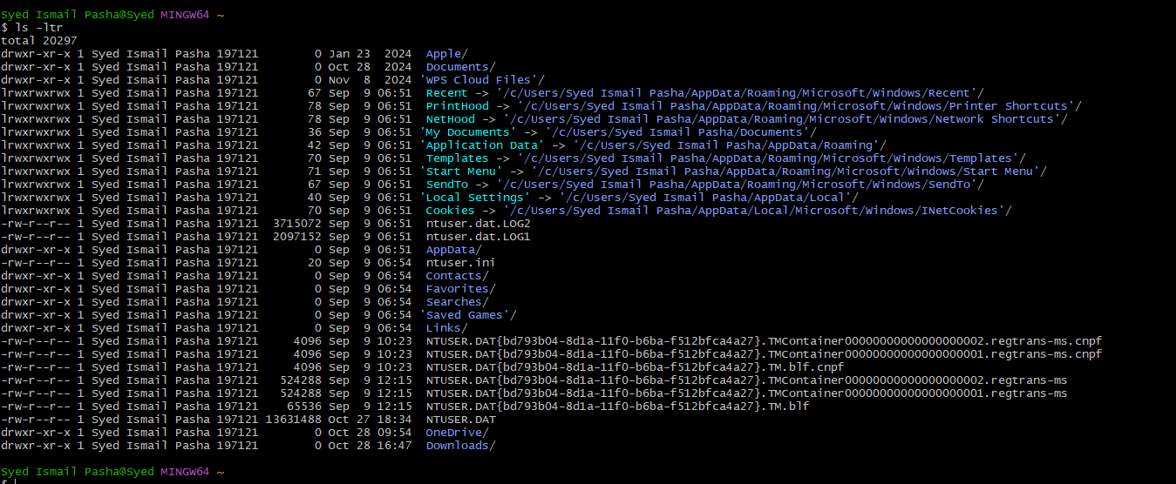
ls -ltr : Display most recent modified file
ls-a: Show hidden files
touch: create a file with byte
mv: move the file
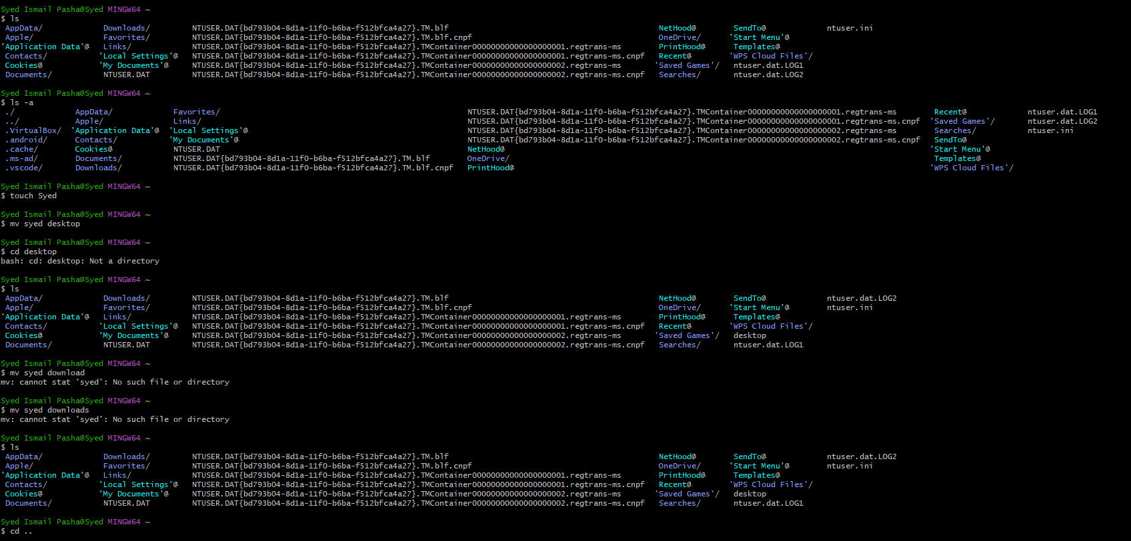

Cd: change directory
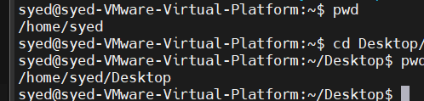

cd .. one step back

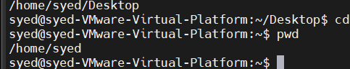

cd ../.. two steps back
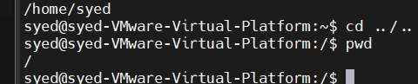

ls -ls : list of file sorting (Higher lume to lower volume)
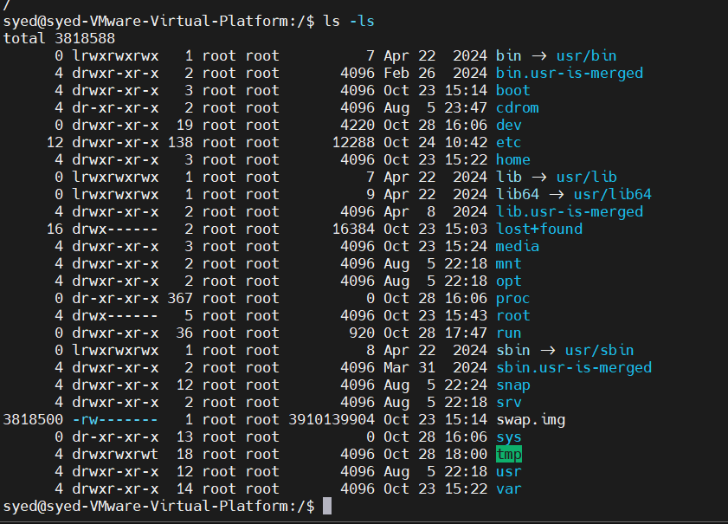

ls: to list files and folder
Mv: move the folder and files or rename
Cd ~: to go directory to home directory
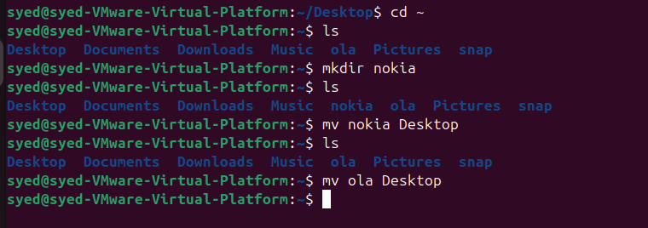
Cat: to view or combine the files
Uname: it will show the system linux
Rm -rf : delete the file

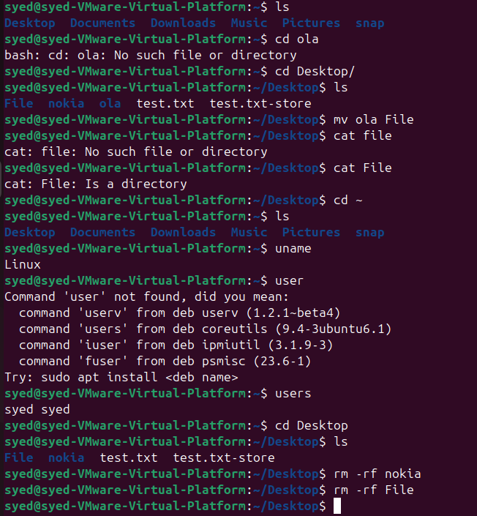

Word count : to count lines, words or characters in a file
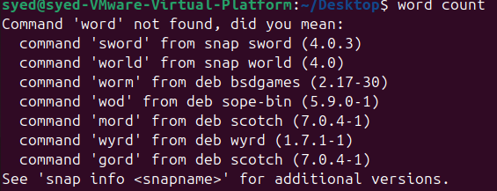

Vi: to edit or create the date in files
